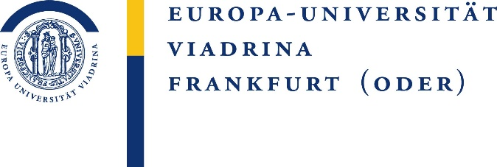

Bachelor Seminar
“International Marketing”
Winter Term 2022/23

Application Form

Name | Click here to enter text.
Matr.no.  Bachelor / Master / PhD:  Faculty: | Click here to enter text.  Bachelor  Business Administration and Economics
Address | Click here to enter text.
E-mail | Click here to enter text.

If you are interested in participating in the seminar, please fill in this application and add a record of your grades (“Notenausdruck” for Bachelor), merge them into one PDF file and upload it on Moodle (Wirtschaftswissenschaftliche Fakultät → WiSe 2022/23 →
LS Marketing (Brunk & Eisend) (Bewerbungsverfahren) → Seminar in Marketing
–“International Marketing”) by October 28, 2022, 1 p.m.
Please note that we accept records in German or English. If you have a different grading system at your home university, please make sure to convert your grades to the German grading system. Only complete applications that arrive in due time will be considered.

